Euclid and The Elements
# Source: AI Source: Provided by: [Data Path: Persons Table -> ID Column: 1, Name_En Column: Motasem Essam] -> From: [ChatGPT] on [7/25/2026]
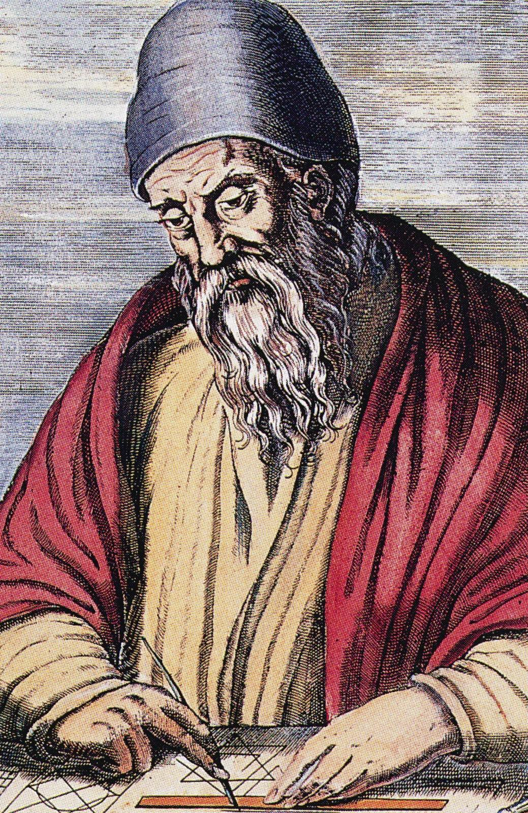
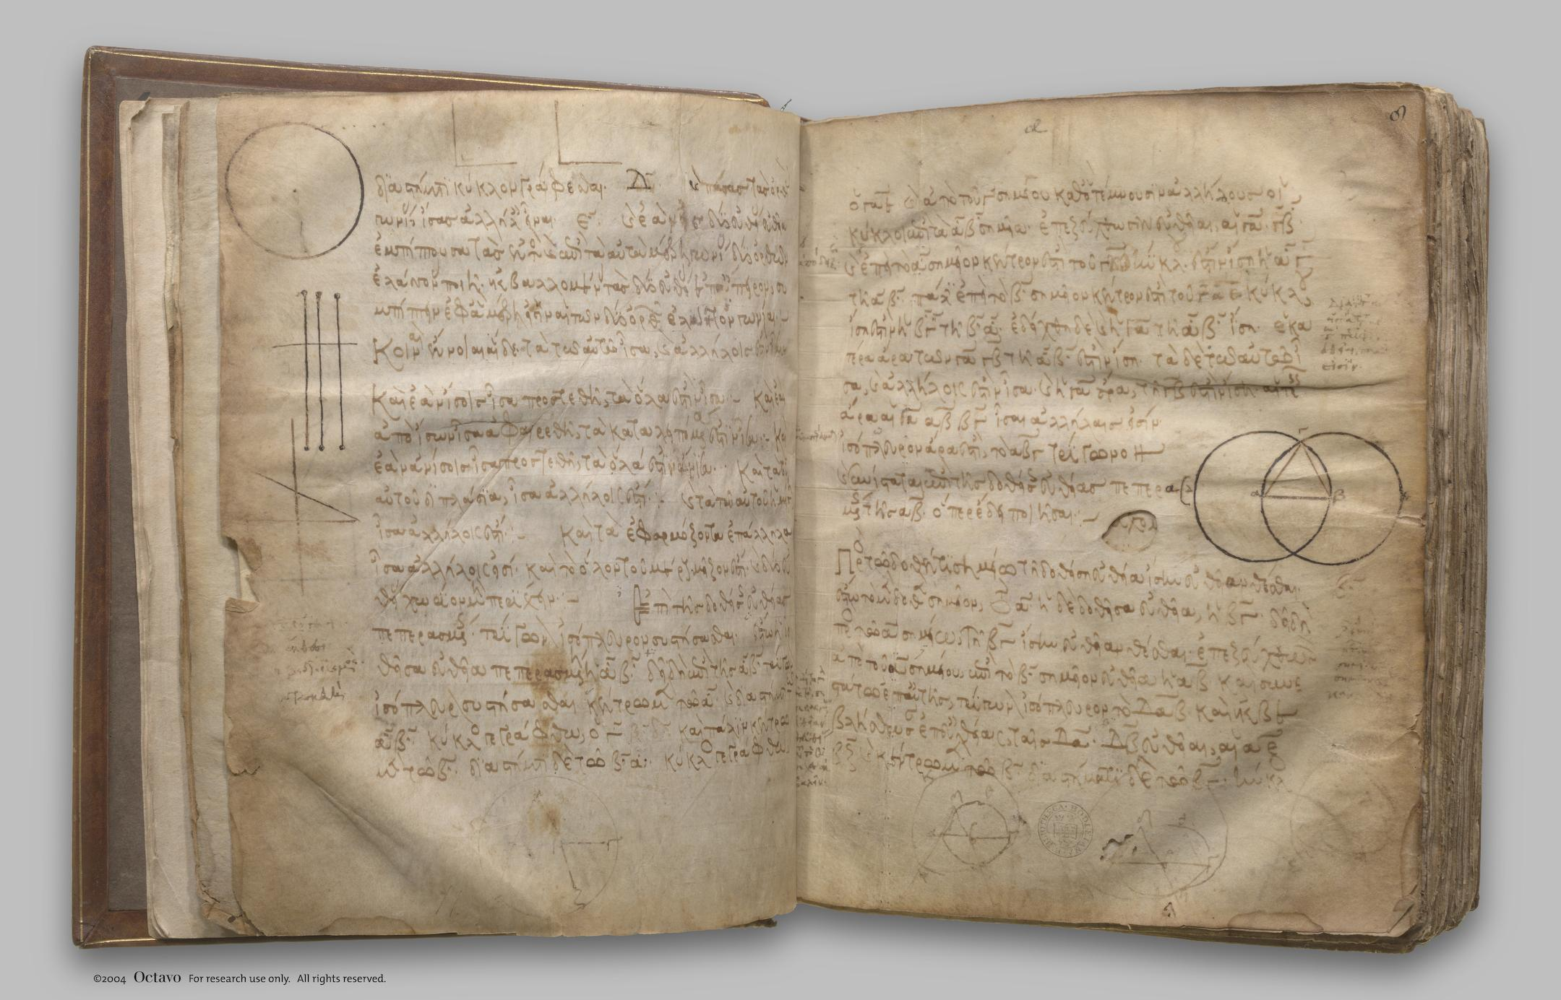
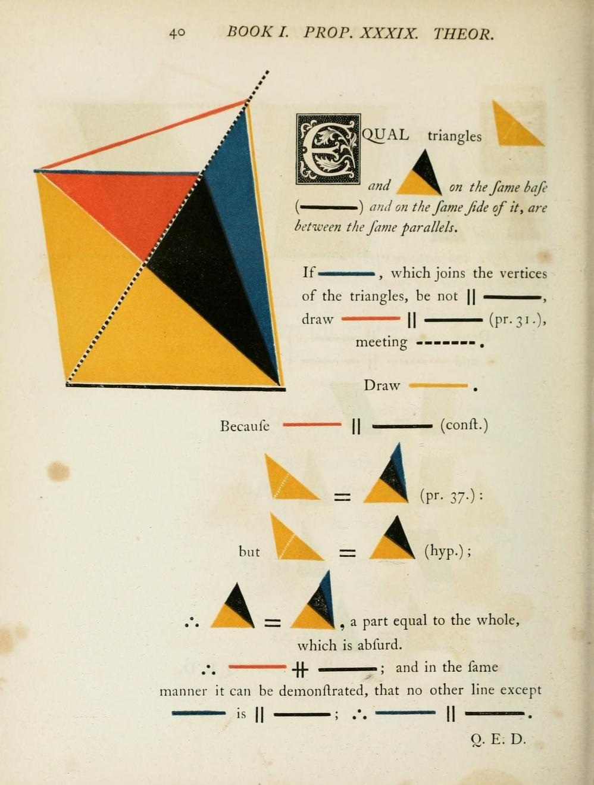
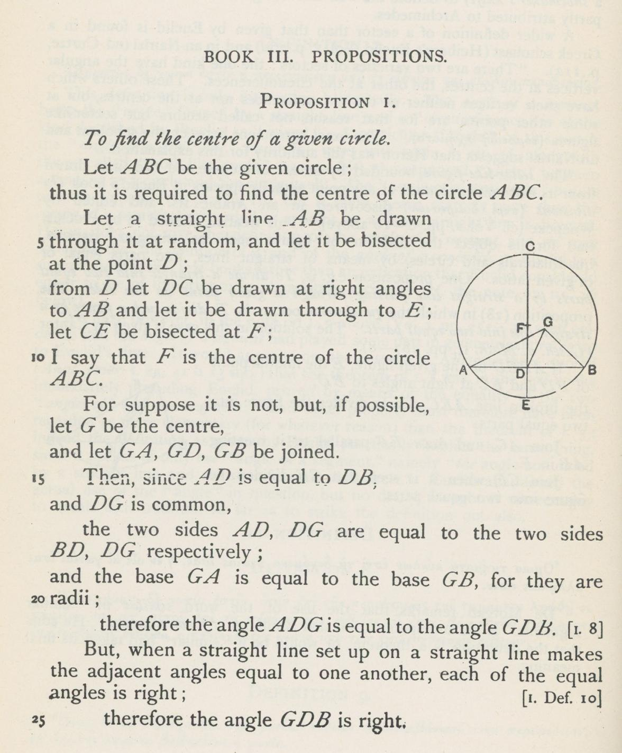
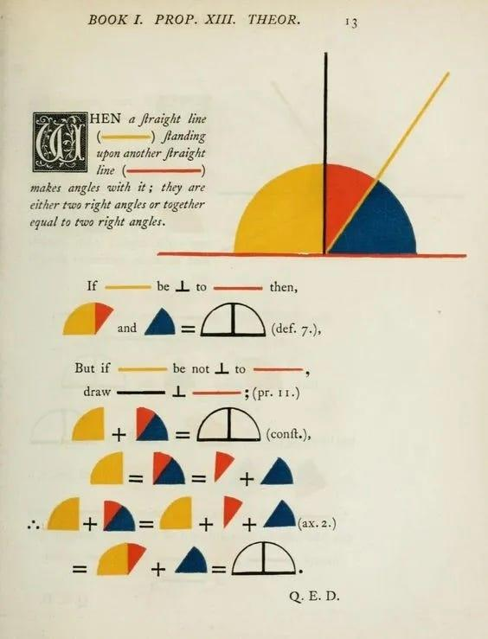

Definition
# Source: AI Source: Provided by: [Data Path: Persons Table -> ID Column: 1, Name_En Column: Motasem Essam] -> From: [ChatGPT] on [7/25/2026]
Euclid and The Elements refers to the work of Euclid of Alexandria and his mathematical treatise Elements, one of the most influential works in the history of mathematics.
Euclid was a Greek mathematician who was active around 300 BCE, probably in Alexandria, Egypt. Very little is known with certainty about his personal life.
His most famous work, The Elements, systematically organized mathematical knowledge using:
- Definitions
- Axioms and common notions
- Postulates
- Propositions
- Proofs
- Geometric constructions
Although The Elements is strongly associated with Euclidean Geometry, it also contains substantial material on number theory, ratios, proportions, and solid geometry.

Euclid
# Source: AI Source: Provided by: [Data Path: Persons Table -> ID Column: 1, Name_En Column: Motasem Essam] -> From: [ChatGPT] on [7/25/2026]
Who Was Euclid?
Euclid of Alexandria was an ancient Greek mathematician who lived during the Hellenistic period.
He is traditionally considered one of the most important figures in the history of geometry because of the systematic way in which The Elements presents mathematical knowledge.
Euclid's importance is not necessarily that he personally discovered every theorem in The Elements. Much of the mathematics was based on earlier work by mathematicians such as:
- Thales
- Pythagoras and the Pythagorean tradition
- Eudoxus
- Theaetetus
- Other earlier Greek mathematicians
Euclid's major achievement was to organize mathematical knowledge into a coherent deductive system.

The Elements
# Source: AI Source: Provided by: [Data Path: Persons Table -> ID Column: 1, Name_En Column: Motasem Essam] -> From: [ChatGPT] on [7/25/2026]
What Is The Elements?
The Elements is a mathematical treatise traditionally attributed to Euclid.
It consists of:
$$\boxed{13\text{ Books}}$$
The work covers a broad range of mathematics, including:
- Plane geometry.
- Geometric constructions.
- Proportions.
- Number theory.
- Incommensurable magnitudes.
- Solid geometry.
- Regular polyhedra.
It is therefore incorrect to think of The Elements as merely a book about shapes.

Purpose of The Elements
# Source: AI Source: Provided by: [Data Path: Persons Table -> ID Column: 1, Name_En Column: Motasem Essam] -> From: [ChatGPT] on [7/25/2026]
The work aimed to present mathematical knowledge in a logical, systematic, deductive form.
Its general structure can be represented as:
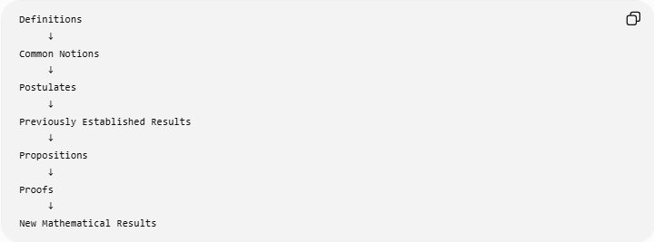
Definitions
↓
Common Notions
↓
Postulates
↓
Previously Established Results
↓
Propositions
↓
Proofs
↓
New Mathematical Results
This structure became an important model for mathematical reasoning.

Euclid's Axiomatic Approach
# Source: AI Source: Provided by: [Data Path: Persons Table -> ID Column: 1, Name_En Column: Motasem Essam] -> From: [ChatGPT] on [7/25/2026]
One of the most important features of The Elements is its axiomatic method.
Instead of proving every statement from scratch, Euclid begins with fundamental assumptions and uses logical reasoning to derive further results.
The basic idea is:
$$\boxed{\text{Basic assumptions}→\text{Logical deductions}→\text{Theorems}}$$
This approach is one of the defining characteristics of classical Euclidean Geometry.

Definitions
# Source: AI Source: Provided by: [Data Path: Persons Table -> ID Column: 1, Name_En Column: Motasem Essam] -> From: [ChatGPT] on [7/25/2026]
At the beginning of The Elements, Euclid introduces definitions for fundamental geometric concepts.
Examples include concepts corresponding to:
- Point.
- Line.
- Straight line.
- Surface.
- Angle.
- Circle.
- Diameter.
- Parallel lines.
A famous classical definition describes a point as something having no parts.
In modern mathematical language, a point is treated as an exact location rather than an object with measurable size.

Common Notions
# Source: AI Source: Provided by: [Data Path: Persons Table -> ID Column: 1, Name_En Column: Motasem Essam] -> From: [ChatGPT] on [7/25/2026]
Euclid also uses general principles called Common Notions.
Examples include principles equivalent to:

Common Notion 1
# Source: AI Source: Provided by: [Data Path: Persons Table -> ID Column: 1, Name_En Column: Motasem Essam] -> From: [ChatGPT] on [7/25/2026]
Things equal to the same thing are equal to each other.
$$a=b, b=c$$
therefore:
$$\boxed{a=c}$$

Common Notion 2
# Source: AI Source: Provided by: [Data Path: Persons Table -> ID Column: 1, Name_En Column: Motasem Essam] -> From: [ChatGPT] on [7/25/2026]
If equals are added to equals, the results are equal.
$$a=b$$
therefore:
$$\boxed{a+c=b+c}$$

Common Notion 3
# Source: AI Source: Provided by: [Data Path: Persons Table -> ID Column: 1, Name_En Column: Motasem Essam] -> From: [ChatGPT] on [7/25/2026]
If equals are subtracted from equals, the remainders are equal.
$$a=b$$
therefore:
$$\boxed{a-c=b-c}$$
These are general logical principles rather than specifically geometric assumptions.

Euclid's Five Postulates
# Source: AI Source: Provided by: [Data Path: Persons Table -> ID Column: 1, Name_En Column: Motasem Essam] -> From: [ChatGPT] on [7/25/2026]
Euclid's geometry begins with five famous geometrical postulates.

Postulate 1
# Source: AI Source: Provided by: [Data Path: Persons Table -> ID Column: 1, Name_En Column: Motasem Essam] -> From: [ChatGPT] on [7/25/2026]
A straight line can be drawn from any point to any point.
Modern interpretation:
Given two distinct points, a straight line segment can be constructed between them.

Postulate 2
# Source: AI Source: Provided by: [Data Path: Persons Table -> ID Column: 1, Name_En Column: Motasem Essam] -> From: [ChatGPT] on [7/25/2026]
A finite straight line can be extended continuously in a straight line.
In modern terms, a line segment can be extended beyond its endpoints.

Postulate 3
# Source: AI Source: Provided by: [Data Path: Persons Table -> ID Column: 1, Name_En Column: Motasem Essam] -> From: [ChatGPT] on [7/25/2026]
A circle can be constructed with any center and radius.
Thus, given a point $O$and a distance $r$, a circle can be constructed centered at $O$.

Postulate 4
# Source: AI Source: Provided by: [Data Path: Persons Table -> ID Column: 1, Name_En Column: Motasem Essam] -> From: [ChatGPT] on [7/25/2026]
All right angles are equal.
Therefore:
$$\boxed{{90}^{∘}={90}^{∘}}$$
for any right angle.

Postulate 5 — Parallel Postulate
# Source: AI Source: Provided by: [Data Path: Persons Table -> ID Column: 1, Name_En Column: Motasem Essam] -> From: [ChatGPT] on [7/25/2026]
The fifth postulate concerns parallel lines.
A commonly used modern equivalent is:
Through a point not on a given line, exactly one line can be drawn parallel to the given line.
This postulate became particularly important because mathematicians later investigated whether it could be derived from the other postulates.

The 13 Books of The Elements
# Source: AI Source: Provided by: [Data Path: Persons Table -> ID Column: 1, Name_En Column: Motasem Essam] -> From: [ChatGPT] on [7/25/2026]
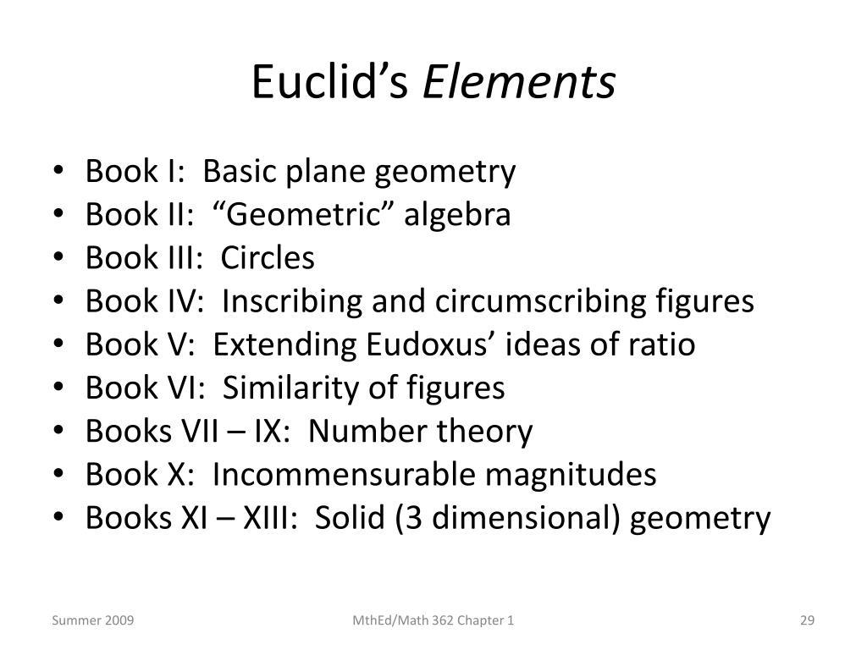
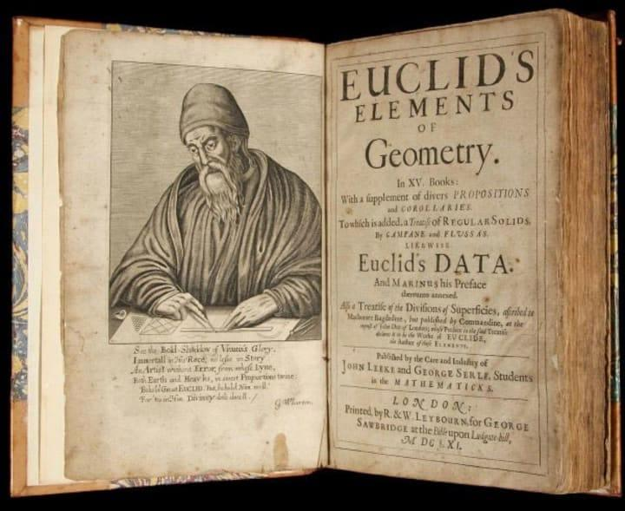
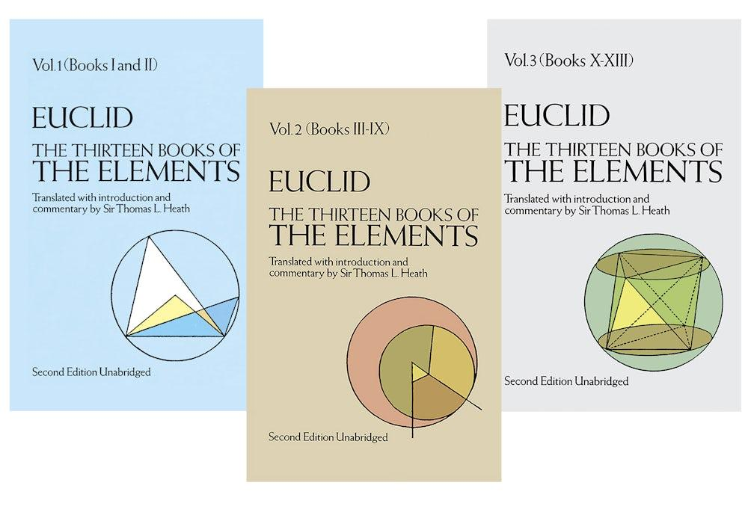
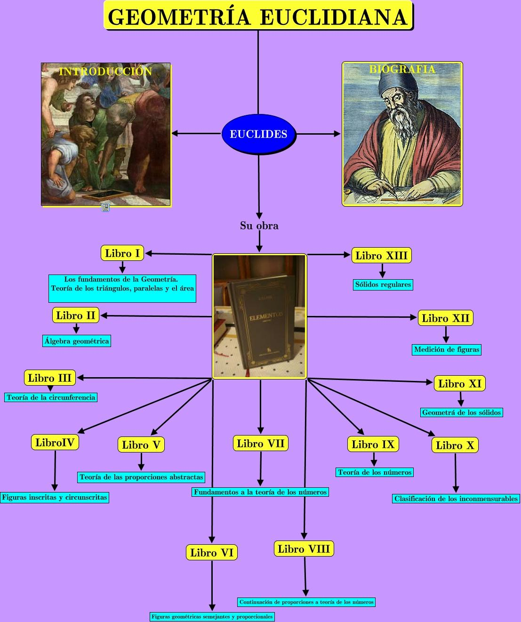
The 13 Books can be broadly summarized as follows.
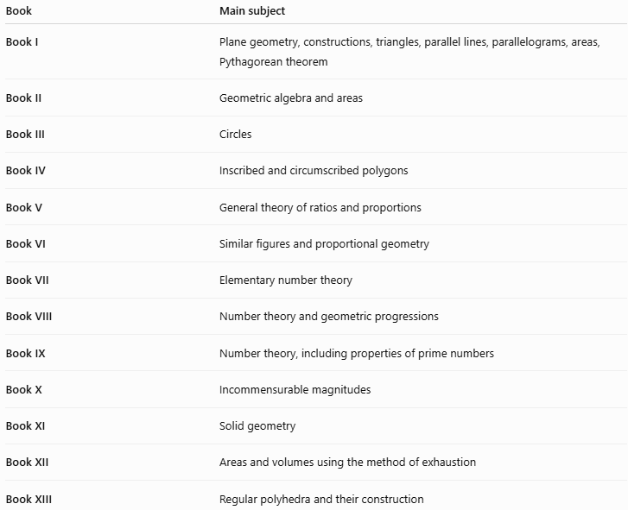
Book | Main subject
Book I | Plane geometry, constructions, triangles, parallel lines, parallelograms, areas, Pythagorean theorem
Book II | Geometric algebra and areas
Book III | Circles
Book IV | Inscribed and circumscribed polygons
Book V | General theory of ratios and proportions
Book VI | Similar figures and proportional geometry
Book VII | Elementary number theory
Book VIII | Number theory and geometric progressions
Book IX | Number theory, including properties of prime numbers
Book X | Incommensurable magnitudes
Book XI | Solid geometry
Book XII | Areas and volumes using the method of exhaustion
Book XIII | Regular polyhedra and their construction
This makes The Elements much broader than a simple geometry textbook.

Book I
# Source: AI Source: Provided by: [Data Path: Persons Table -> ID Column: 1, Name_En Column: Motasem Essam] -> From: [ChatGPT] on [7/25/2026]
Book I is particularly important for Euclidean Geometry.
It begins with basic definitions, postulates, and common notions and develops increasingly sophisticated geometric results.
Topics include:
- Construction of an equilateral triangle.
- Congruence relationships.
- Isosceles triangles.
- Parallel lines.
- Angle relationships.
- Parallelograms.
- Areas.
- Triangles.
- The Pythagorean theorem.
One of the famous final results of Book I is the Pythagorean Theorem.
For a right triangle:
$$\boxed{a^{2}+b^{2}=c^{2}}$$

Book II
# Source: AI Source: Provided by: [Data Path: Persons Table -> ID Column: 1, Name_En Column: Motasem Essam] -> From: [ChatGPT] on [7/25/2026]
Book II deals largely with geometric relationships involving areas.
It contains propositions that can be interpreted using what modern mathematics calls geometric algebra.
For example, identities such as:
$${\left(a+b\right)}^{2}=a^{2}+2ab+b^{2}$$
can be represented geometrically using squares and rectangles.
This is an important historical example of how algebraic relationships were studied geometrically before modern symbolic algebra developed.

Book III — Circles
# Source: AI Source: Provided by: [Data Path: Persons Table -> ID Column: 1, Name_En Column: Motasem Essam] -> From: [ChatGPT] on [7/25/2026]
Book III focuses on circles.
Topics include:
- Chords.
- Angles.
- Tangency.
- Intersections.
- Properties of circles.
- Relationships between lines and circles.
Important concepts include:
$$\boxed{\text{radius}} \\ \boxed{\text{diameter}} \\ \boxed{\text{chord}} \\ \boxed{\text{tangent}}$$

Book IV — Polygons and Circles
# Source: AI Source: Provided by: [Data Path: Persons Table -> ID Column: 1, Name_En Column: Motasem Essam] -> From: [ChatGPT] on [7/25/2026]
Book IV studies relationships between polygons and circles.
It includes constructions involving:
- Inscribed polygons.
- Circumscribed polygons.
- Regular polygons.
- Circles.
For example, a polygon can be inscribed in a circle when all of its vertices lie on the circle.

Book V — Ratios and Proportions
# Source: AI Source: Provided by: [Data Path: Persons Table -> ID Column: 1, Name_En Column: Motasem Essam] -> From: [ChatGPT] on [7/25/2026]
Book V develops a general theory of ratios and proportions, associated especially with the work of Eudoxus.
This was important because it allowed geometric magnitudes to be treated systematically, including magnitudes that could not be expressed as simple ratios of integers.

Book VI — Similarity
# Source: AI Source: Provided by: [Data Path: Persons Table -> ID Column: 1, Name_En Column: Motasem Essam] -> From: [ChatGPT] on [7/25/2026]
Book VI applies the theory of ratios and proportions to geometry.
Important topics include:
- Similar triangles.
- Proportional segments.
- Similar figures.
- Geometric mean.
- Division of segments.
- Relationships between areas.
For similar triangles:
$$\frac{AB}{DE}=\frac{BC}{EF}=\frac{AC}{DF}$$

Books VII–IX — Number Theory
# Source: AI Source: Provided by: [Data Path: Persons Table -> ID Column: 1, Name_En Column: Motasem Essam] -> From: [ChatGPT] on [7/25/2026]
An important feature of The Elements is that it is not purely geometric.
Books VII, VIII, and IX deal extensively with number theory.
Topics include:
- Divisibility.
- Prime numbers.
- Greatest common divisor.
- Ratios of numbers.
- Perfect numbers.
- Geometric progressions.
A famous result in Book IX is the infinitude of prime numbers.
In modern notation:
$$\boxed{\text{There are infinitely many prime numbers}}$$

Book X — Incommensurable Magnitudes
# Source: AI Source: Provided by: [Data Path: Persons Table -> ID Column: 1, Name_En Column: Motasem Essam] -> From: [ChatGPT] on [7/25/2026]
Book X deals with incommensurable magnitudes.
Two magnitudes are commensurable if there is a common unit that measures both exactly.
For example:
$$2\text{ cm}$$
and:
$$3\text{ cm}$$
are commensurable.
But the side and diagonal of a square are incommensurable because:
$$d=s\sqrt{2}$$
and:
$$\sqrt{2}$$
cannot be expressed as a ratio of two integers.
This topic was historically important in the development of the concept of irrational quantities.

Books XI–XIII — Solid Geometry
# Source: AI Source: Provided by: [Data Path: Persons Table -> ID Column: 1, Name_En Column: Motasem Essam] -> From: [ChatGPT] on [7/25/2026]
The final books extend geometry into three dimensions.
Topics include:
- Lines and planes.
- Solid figures.
- Prisms.
- Pyramids.
- Spheres.
- Polyhedra.
- Regular polyhedra.

The Five Platonic Solids
# Source: AI Source: Provided by: [Data Path: Persons Table -> ID Column: 1, Name_En Column: Motasem Essam] -> From: [ChatGPT] on [7/25/2026]
Book XIII is especially famous for its treatment of the five regular polyhedra, commonly called the Platonic solids:
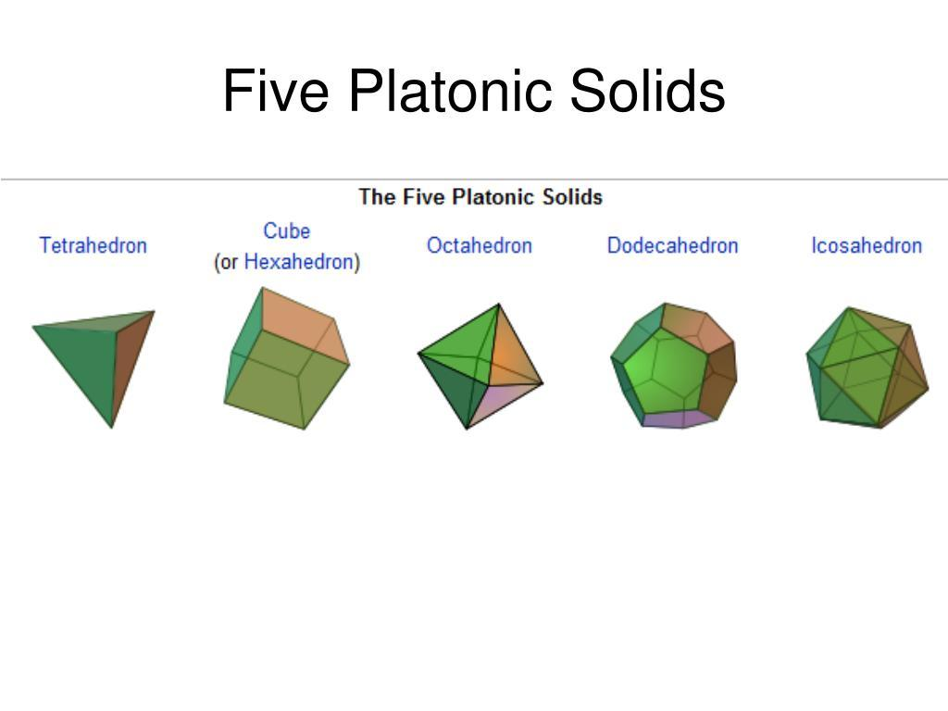
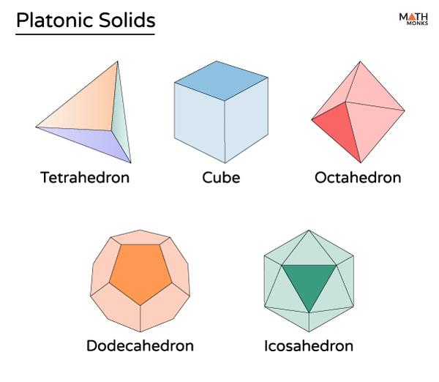
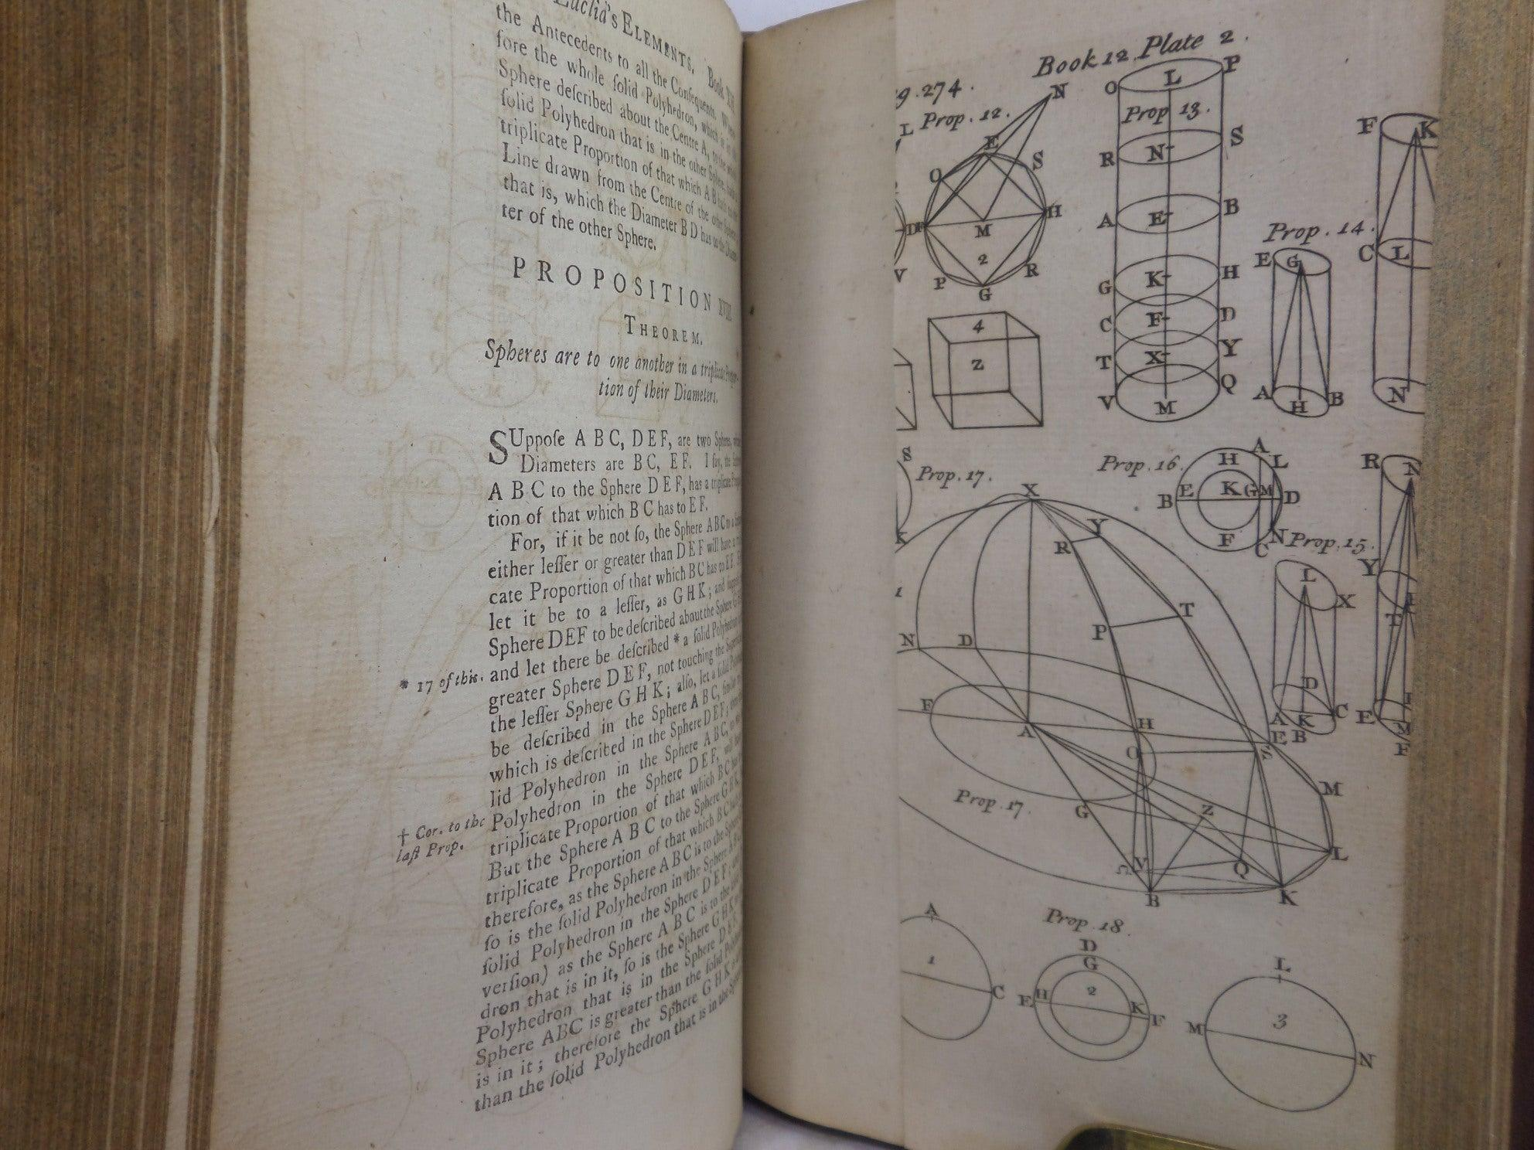
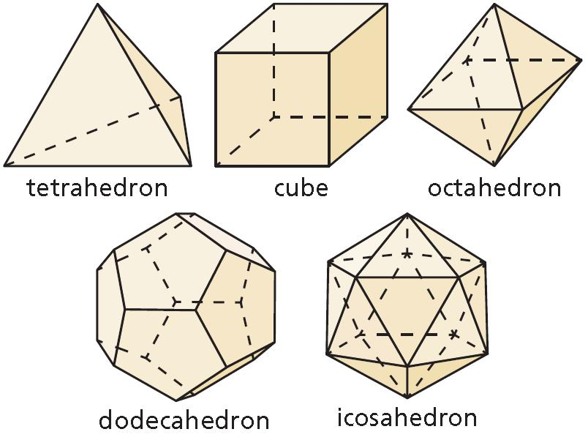
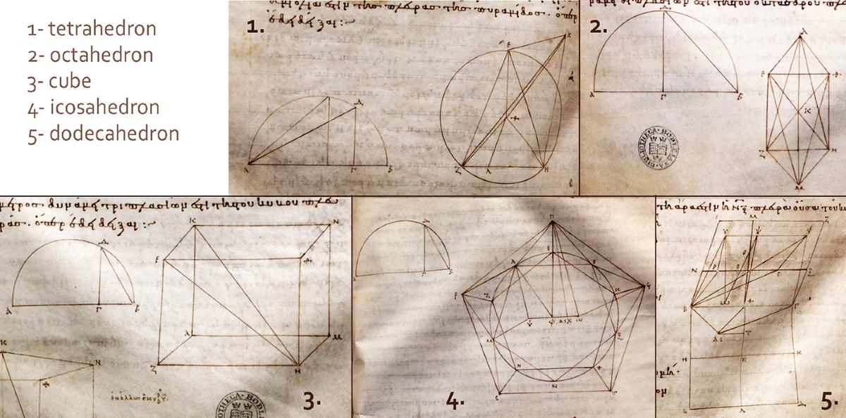
- Tetrahedron
- Cube
- Octahedron
- Dodecahedron
- Icosahedron
These are convex polyhedra whose faces are congruent regular polygons and whose vertices have the same local configuration.

Euclidean Construction
# Source: AI Source: Provided by: [Data Path: Persons Table -> ID Column: 1, Name_En Column: Motasem Essam] -> From: [ChatGPT] on [7/25/2026]
A major feature of The Elements is geometric construction.
Classical Euclidean constructions use:
- A straightedge.
- A compass.
Examples include:
Equilateral Triangle
Given segment $AB$:
- Draw a circle centered at $A$with radius $AB$.
- Draw a circle centered at $B$with radius $AB$.
- Let their intersection be $C$.
- Connect $A$to $C$and $B$to $C$.
Then:
$$AB=BC=CA$$
Therefore:
$$\boxed{△ABC\text{ is equilateral}}$$

Proposition and Proof
# Source: AI Source: Provided by: [Data Path: Persons Table -> ID Column: 1, Name_En Column: Motasem Essam] -> From: [ChatGPT] on [7/25/2026]
A proposition in The Elements is a mathematical statement that is established through reasoning.
A typical Euclidean proof follows a structure similar to:
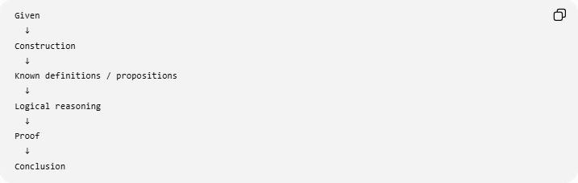
Given
↓
Construction
↓
Known definitions / propositions
↓
Logical reasoning
↓
Proof
↓
Conclusion
This approach is one of the most important contributions of The Elements to the history of mathematics.

Euclid's Influence
# Source: AI Source: Provided by: [Data Path: Persons Table -> ID Column: 1, Name_En Column: Motasem Essam] -> From: [ChatGPT] on [7/25/2026]
The Elements became one of the most influential mathematical texts ever written.
Its influence extended to:
- Mathematics.
- Philosophy.
- Logic.
- Science.
- Engineering.
- Architecture.
- Education.
For centuries, it was used as a major mathematical textbook.
Its importance comes not only from the geometric results it contains, but also from its method of organizing knowledge through deduction.

Transmission of The Elements
# Source: AI Source: Provided by: [Data Path: Persons Table -> ID Column: 1, Name_En Column: Motasem Essam] -> From: [ChatGPT] on [7/25/2026]
After antiquity, The Elements survived through manuscript traditions and was transmitted across different cultures.
Greek mathematical works were translated into Arabic during the medieval period and were studied and developed by scholars in the Islamic world.
Later, The Elements was translated into Latin and became widely available in medieval and Renaissance Europe.
The development can be summarized:
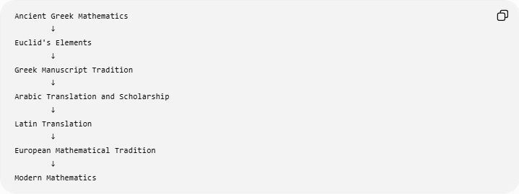
Ancient Greek Mathematics
↓
Euclid's Elements
↓
Greek Manuscript Tradition
↓
Arabic Translation and Scholarship
↓
Latin Translation
↓
European Mathematical Tradition
↓
Modern Mathematics

Euclid vs. The Elements
# Source: AI Source: Provided by: [Data Path: Persons Table -> ID Column: 1, Name_En Column: Motasem Essam] -> From: [ChatGPT] on [7/25/2026]
It is important to distinguish the mathematician from the work.
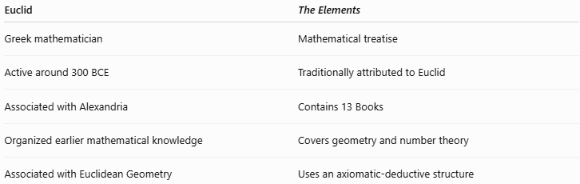
Euclid | The Elements
Greek mathematician | Mathematical treatise
Active around 300 BCE | Traditionally attributed to Euclid
Associated with Alexandria | Contains 13 Books
Organized earlier mathematical knowledge | Covers geometry and number theory
Associated with Euclidean Geometry | Uses an axiomatic-deductive structure

Euclid's Elements vs Modern Geometry
# Source: AI Source: Provided by: [Data Path: Persons Table -> ID Column: 1, Name_En Column: Motasem Essam] -> From: [ChatGPT] on [7/25/2026]
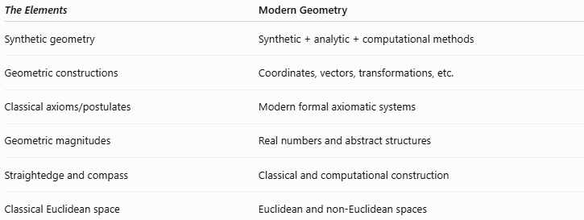
The Elements | Modern Geometry
Synthetic geometry | Synthetic + analytic + computational methods
Geometric constructions | Coordinates, vectors, transformations, etc.
Classical axioms/postulates | Modern formal axiomatic systems
Geometric magnitudes | Real numbers and abstract structures
Straightedge and compass | Classical and computational construction
Classical Euclidean space | Euclidean and non-Euclidean spaces
Modern mathematics has significantly expanded the foundations and language of geometry, but many classical results from The Elements remain fundamental.

Euclid and the Development of Mathematical Proof
# Source: AI Source: Provided by: [Data Path: Persons Table -> ID Column: 1, Name_En Column: Motasem Essam] -> From: [ChatGPT] on [7/25/2026]
One of the most important historical contributions associated with The Elements is the demonstration that mathematics can be organized as a deductive system.
The basic principle is:
$$\boxed{\text{Assumptions}→\text{Reasoning}→\text{Proof}→\text{Theorem}}$$
This idea influenced later mathematical disciplines far beyond geometry.

The Parallel Postulate and Later Mathematics
# Source: AI Source: Provided by: [Data Path: Persons Table -> ID Column: 1, Name_En Column: Motasem Essam] -> From: [ChatGPT] on [7/25/2026]
The fifth postulate eventually became one of the most famous problems in mathematics.
For centuries, mathematicians attempted to prove it from the other postulates.
These investigations eventually contributed to the discovery of:
- Hyperbolic Geometry.
- Spherical Geometry.
- Non-Euclidean Geometry.
- Modern axiomatic geometry.
Thus:
$$\boxed{\text{Euclid’s Parallel Postulate}→\text{Study of Alternatives}→\text{Non-Euclidean Geometry}}$$

Historical Timeline
# Source: AI Source: Provided by: [Data Path: Persons Table -> ID Column: 1, Name_En Column: Motasem Essam] -> From: [ChatGPT] on [7/25/2026]
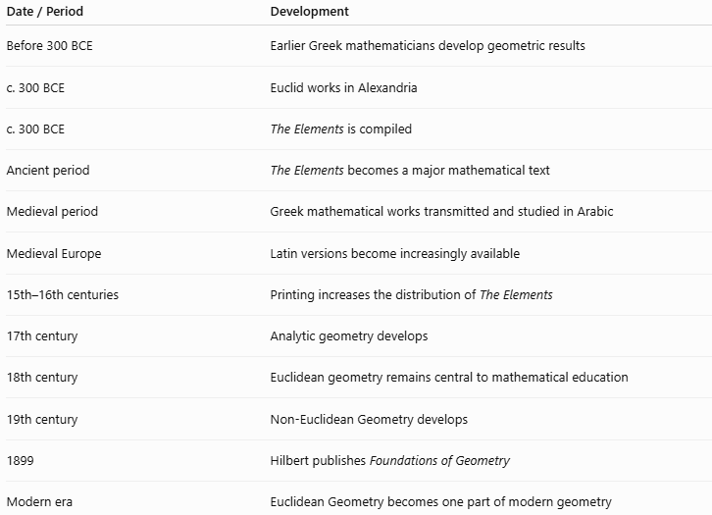
Date / Period | Development
Before 300 BCE | Earlier Greek mathematicians develop geometric results
c. 300 BCE | Euclid works in Alexandria
c. 300 BCE | The Elements is compiled
Ancient period | The Elements becomes a major mathematical text
Medieval period | Greek mathematical works transmitted and studied in Arabic
Medieval Europe | Latin versions become increasingly available
15th–16th centuries | Printing increases the distribution of The Elements
17th century | Analytic geometry develops
18th century | Euclidean geometry remains central to mathematical education
19th century | Non-Euclidean Geometry develops
1899 | Hilbert publishes Foundations of Geometry
Modern era | Euclidean Geometry becomes one part of modern geometry

Relationship with Euclidean Geometry
# Source: AI Source: Provided by: [Data Path: Persons Table -> ID Column: 1, Name_En Column: Motasem Essam] -> From: [ChatGPT] on [7/25/2026]
The relationship can be represented as:
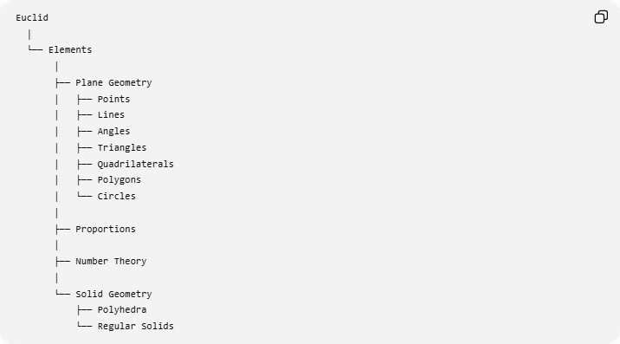
Euclid
│
└── Elements
│
├── Plane Geometry
│ ├── Points
│ ├── Lines
│ ├── Angles
│ ├── Triangles
│ ├── Quadrilaterals
│ ├── Polygons
│ └── Circles
│
├── Proportions
│
├── Number Theory
│
└── Solid Geometry
├── Polyhedra
└── Regular Solids

Real-World Applications
# Source: AI Source: Provided by: [Data Path: Persons Table -> ID Column: 1, Name_En Column: Motasem Essam] -> From: [ChatGPT] on [7/25/2026]
The principles developed and organized in The Elements influenced applications in:
- Architecture.
- Construction.
- Surveying.
- Engineering.
- Astronomy.
- Navigation.
- Cartography.
- Mechanical design.
- Education.
- Computer graphics.

Advantages
# Source: AI Source: Provided by: [Data Path: Persons Table -> ID Column: 1, Name_En Column: Motasem Essam] -> From: [ChatGPT] on [7/25/2026]
The Elements was historically important because it:
- Organized mathematical knowledge systematically.
- Demonstrated deductive mathematical reasoning.
- Provided rigorous geometric proofs.
- Preserved earlier mathematical knowledge.
- Established a model for axiomatic mathematics.
- Connected geometry with number theory and proportions.
- Influenced mathematical education for centuries.

Limitations
# Source: AI Source: Provided by: [Data Path: Persons Table -> ID Column: 1, Name_En Column: Motasem Essam] -> From: [ChatGPT] on [7/25/2026]
From a modern perspective:
- The original mathematical language is not the same as modern mathematical notation.
- Some historical attributions of individual results are uncertain.
- The work does not represent all modern mathematical foundations.
- Modern geometry distinguishes more carefully between axioms, definitions, models, and logical systems.
- Euclidean Geometry describes flat space and does not encompass all possible geometries.

Key Points
# Source: AI Source: Provided by: [Data Path: Persons Table -> ID Column: 1, Name_En Column: Motasem Essam] -> From: [ChatGPT] on [7/25/2026]
- Euclid was a Greek mathematician associated with Alexandria, active around 300 BCE.
- His most famous work is The Elements.
- The Elements contains 13 Books.
- It covers much more than geometry, including number theory and proportions.
- Its geometric foundation uses:
  - Definitions
  - Common notions
  - Postulates
  - Propositions
  - Proofs
- The famous five Euclidean postulates are central to Book I.
- The Parallel Postulate later became the starting point for the development of non-Euclidean geometry.
- The Elements contains classical results including the Pythagorean Theorem.
- Books XI–XIII develop solid geometry and the five Platonic solids.
- Euclid's greatest historical importance lies not simply in discovering individual theorems, but in presenting mathematics through a systematic deductive framework.

Conclusion
# Source: AI Source: Provided by: [Data Path: Persons Table -> ID Column: 1, Name_En Column: Motasem Essam] -> From: [ChatGPT] on [7/25/2026]
Euclid and The Elements occupy a central position in the history of mathematics. Euclid did not create all of the mathematics contained in The Elements; instead, he organized a substantial body of earlier mathematical knowledge into a systematic deductive work.
The 13 Books cover plane geometry, proportions, number theory, incommensurable magnitudes, solid geometry, and regular polyhedra. Through its use of definitions, postulates, common notions, propositions, and proofs, The Elements established a model of mathematical reasoning that influenced mathematics for more than two millennia.
Its influence can be summarized as:
$$\boxed{\text{Ancient Geometry}→\text{Euclid’s Elements}→\text{Axiomatic Geometry}→\text{Modern Mathematics}}$$
For your knowledge-base hierarchy, “Euclid and The Elements” fits naturally under History of Euclidean Geometry, while “Euclid's Five Postulates” and “Euclidean Axiomatic Method” can be separate related topics.

